Cybersecurity Incident Report:

Network Traffic Analysis
Incident Summery:

You are a cybersecurity analyst working at a company that specializes in providing IT services for clients. Several customers of clients reported that they were not able to access the client company website www.yummyrecipesforme.com, and saw the error “destination port unreachable” after waiting for the page to load.
You are tasked with analyzing the situation and determining which network protocol was affected during this incident. To start, you attempt to visit the website and you also receive the error “destination port unreachable.” To troubleshoot the issue, you load your network analyzer tool, tcpdump, and attempt to load the webpage again. To load the webpage, your browser sends a query to a DNS server via the UDP protocol to retrieve the IP address for the website's domain name; this is part of the DNS protocol. Your browser then uses this IP address as the destination IP for sending an HTTPS request to the web server to display the webpage The analyzer shows that when you send UDP packets to the DNS server, you receive ICMP packets containing the error message: “udp port 53 unreachable.”
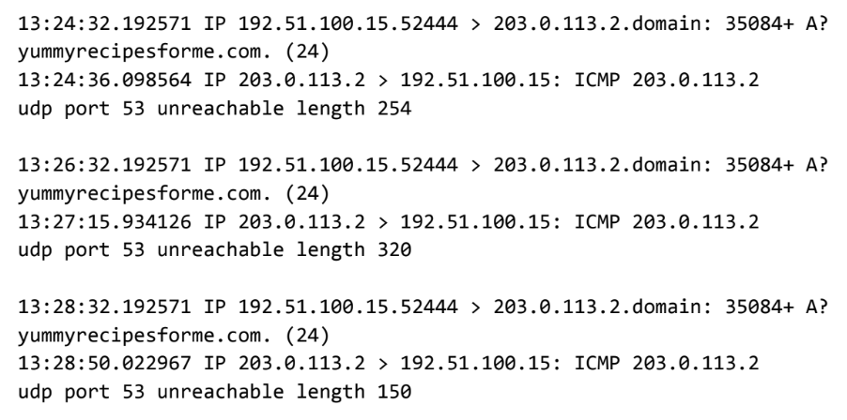

Part 1: Provide a summary of the problem found in the DNS and ICMP
traffic log.

The UDP protocol reveals that:
That the DNS protocol can not be reached, indicated by “udp port 53 is unreachable” IMCP error message

This is based on the results of the network analysis, which show that the ICMP echo reply returned the error message:
“udp port 53 unreachable”

The port noted in the error message is used for:
Standard DNS lookups

The most likely issue is:
The DNS service on the destination server was either stopped, misconfigured, or blocked by a firewall, resulting in UDP port 53 being unreachable.

Part 2: Explain your analysis of the data and provide at least one cause of the incident.
Time incident occurred:
12:24:32.192571 or 1:24 p.m., 32.192571 seconds

Explain how the IT team became aware of the incident:
End-users have reported client company website www.yummyrecipesforme.com inaccessible, and received the error “destination port unreachable” after waiting for the page to load.

Explain the actions taken by the IT department to investigate the incident:
The IT team replicated the issue, captured packets with tcpdump, and observed that outbound UDP queries to the DNS server generated ICMP responses indicating “udp port 53 unreachable.” This confirmed a failure in the DNS resolution process preceding the HTTPS request.

Note key findings of the IT department's investigation (i.e., details related to the port affected, DNS server, etc.):
DNS servers use Port 53 for UDP queries. UDP port 53 is used for standard DNS lookups. If port 53 is unreachable then the DNS server has crashed, or is misconfigured. Alternatively, the firewall may be rejecting the port. However, we have not determined what caused the port to be initially disrupted. Only the possible end results of the disruptions.

Note a likely cause of the incident:
- UDP port 53 on the DNS server is not accepting DNS requests.
- Host/firewall rejecting UDP port 53

